Task 1 - HTML:

<!DOCTYPE html>
<html lang="en">

<head>

<meta charset="UTF-8">
<meta name="viewport" content="width=device-width, initial-scale=1.0">
<meta name="description" content="Portfolio of Avyakth Shriram, CS Student at VIT Chennai">
<title>Avyakth Shriram | Portfolio</title>
<link rel="stylesheet" type="text/css" href="styles.css">

</head>

<body>

<main class="container">
<header class="profile-header">
<h1 class="name-heading">AVYAKTH SHRIRAM</h1>
<div class="separator"></div>
<div class="profile-intro">

<p>
<span class="greeting">Hello!</span> I'm a student at the <strong>Vellore Institute of Technology, Chennai</strong>.
</p>

<p class="subtitle">
I'm currently in my sophomore year and am pursuing a B.Tech in Computer Science & Engineering.
</p>

</div>
</header>
<article class="bio-content">

<p>
<strong>Hostel life</strong> during your <em>student years</em> is always busy and memorable, granted that it can make you irresponsible and reckless too. Getting up early in the morning can be a challenge, but you feel rewarded when you manage to do it.
</p>

<p>
Getting up around 7<sup>00</sup> A.M. and sleeping earlier at night at around 10<sub>00</sub> P.M. is ideal, as it allows you to be sharp throughout the day to navigate all the lectures, labs, and self-study sessions.
</p>

<p>
I enjoy <small><del>skipping</del></small> attending classes (hehe), participating in club activities, and spending some time with my friends in the hostel rooms. Admittedly, this isn't always possible during exam preparations, but you have to learn how to balance academics and fun.
</p>

<p>
Hostel life ultimately shaped me into a (moderately) disciplined individual, blessing me with <ins>better time management, an improved attitude towards teamwork, and lifelong friendships</ins>. I was content by the time I decided to transition into being a day scholar, starting a fresh chapter in my journey as I found myself needing to tilt the balance to favor academics. I'll cherish those memories always.
</p>

</article>
</main>

</body>

</html>

=======================================================================

TASK 1 - CSS:

:root {
--bg-color: #121212;
--text-color: #e0e0e0;
--accent-color: #64ffda;
--secondary-color: #a8b2d1;
--highlight-bg: #1d3b36;
--font-stack: 'Inter', system-ui, -apple-system, sans-serif;
}

body {
background-color: var(--bg-color);
color: var(--text-color);
font-family: var(--font-stack);
line-height: 1.7;
margin: 0;
padding: 2rem 1rem;
}

.container {
max-width: 750px;
margin: 0 auto;
}

.profile-header {
text-align: center;
margin-bottom: 3rem;
}

.name-heading {
color: var(--accent-color);
font-size: 2.5rem;
margin: 0;
letter-spacing: 3px;
font-weight: 800;
}

.separator {
width: 100px;
height: 3px;
background-color: var(--secondary-color);
margin: 1.5rem auto; /* Centers the line */
border-radius: 2px;
}

.greeting {
font-size: 1.5rem;
font-weight: bold;
color: var(--accent-color);
}

.subtitle {
font-style: italic;
color: var(--secondary-color);
margin-top: 0.5rem;
}

.bio-content p {
margin-bottom: 1.5rem;
font-size: 1.125rem;
}

ins {
background-color: var(--highlight-bg);
color: #fff;
text-decoration: none;
padding: 2px 6px;
border-radius: 4px;
border-left: 3px solid var(--accent-color);
}

del {
color: #555;
text-decoration-thickness: 2px;
}

strong {
color: var(--accent-color);
}

sup, sub {
font-size: 0.75em;
color: var(--secondary-color);
}

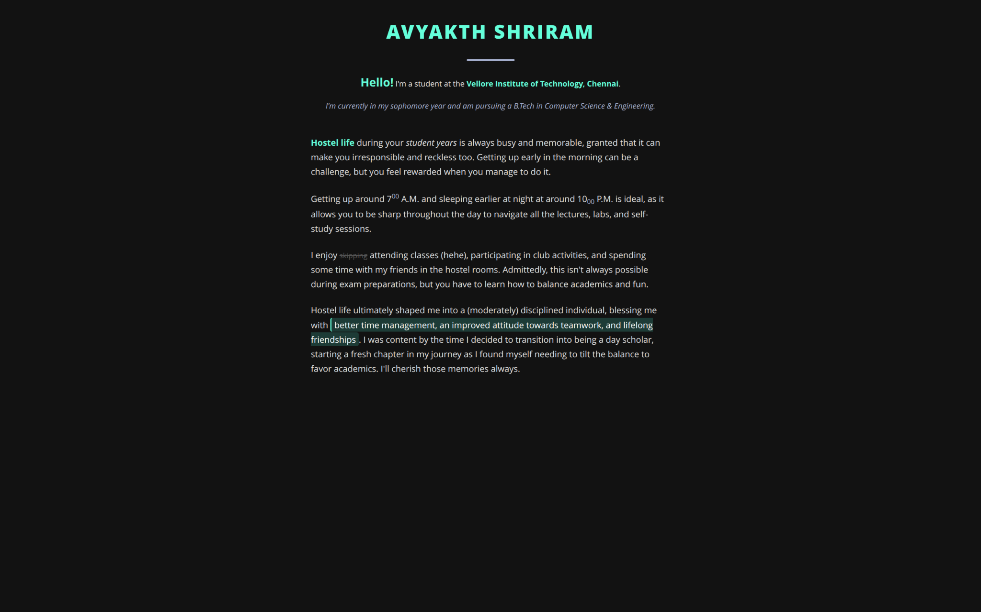

====================================================

====================================================

TASK 2 – HTML:

<!DOCTYPE html>
<html lang="en">

<head>
<meta charset="UTF-8">
<meta name="viewport" content="width=device-width, initial-scale=1.0">
<title>Characteristic Symbols</title>
<link rel="stylesheet" type="text/css" href="styles.css">
</head>

<body>
<main class="container">
<header>
<h1 class="heading">Learning Symbol Representation</h1>
<h4>Today's Topics:</h4>
<ul>
<li>Introduction</li>
<li>Symbols</li>
<li>Conclusion</li>
</ul>
</header>
<section>
<h3>A. Introduction</h3>
<p>Hi! Today we are going to discuss the various Symbols used in HTML using their coded keys (HTML Entities).
</p>
<h3>B. The Symbols</h3>
<table class="symbol-table">
<thead>
<tr>
<th>Symbol Name</th>
<th>The Code</th>
<th>The Result</th>
</tr>
</thead>
<tbody>
<tr>
<td>Non-breaking space</td>
<td><code>&amp;#160;</code></td>
<td class="result">[&#160;]</td>
</tr>
<tr>
<td>Less Than</td>
<td><code>&amp;#60;</code></td>
<td class="result">&#60;</td>
</tr>
<tr>
<td>Greater Than</td>
<td><code>&amp;#62;</code></td>
<td class="result">&#62;</td>
</tr>
<tr>
<td>Ampersand</td>
<td><code>&amp;#38;</code></td>
<td class="result">&#38;</td>
</tr>
<tr>
<td>Quotation Mark</td>
<td><code>&amp;#34;</code></td>
<td class="result">&#34;</td>
</tr>
<tr>
<td>Apostrophe</td>
<td><code>&amp;#39;</code></td>
<td class="result">&#39;</td>
</tr>
<tr>
<td>Copyright</td>
<td><code>&amp;#169;</code></td>
<td class="result">&#169;</td>
</tr>
</tbody>
</table>
<h3>C. Conclusion</h3>
<p>Hence, we have discussed the topics completely.</p>
</section>
<section class="feedback-section">
<dl>
<dt><strong>Feedback:</strong></dt>
<dd>"Very good course, I recommend this to all!"</dd>
</dl>
</section>
<footer class="reach-us">
<p>
Click <a href="https://www.google.com" target="_blank">here</a> for more info.
</p>
<div class="contact-box">
<img class="icon" src="https://cdn-icons-png.flaticon.com/512/732/732200.png" alt="Email Icon"/>
<p><a href="mailto:webmaster@example.com">
Mail us at webmaster@example.com
</a></p>
</div>
</footer>
</main>
</body>
</html>

======================================================================

TASK 2 – CSS:

.symbol-table {
width: 100%;
border-collapse: collapse;
margin: 2rem 0;
background-color: #1e1e1e;
border-radius: 8px;
overflow: hidden;
}

.symbol-table th,
.symbol-table td {
padding: 12px 15px;
text-align: left;
border-bottom: 1px solid #333;
}

.symbol-table th {
background-color: var(--accent-color);
color: var(--bg-color);
font-weight: bold;
text-transform: uppercase;
letter-spacing: 1px;
}

.symbol-table code {
background-color: #333;
padding: 2px 6px;
border-radius: 4px;
font-family: monospace;
color: #ff79c6;
}

.result {
font-size: 1.2rem;
color: var(--accent-color);
}

.contact-box {
background-color: var(--highlight-bg);
padding: 1rem;
border-radius: 8px;
display: flex;
align-items: center;
gap: 1rem;
margin-top: 1rem;
border: 1px solid var(--accent-color);
}

.contact-box a {
color: #fff;
text-decoration: none;
font-weight: bold;
}

.contact-box a:hover {
text-decoration: underline;
}

.icon {
width: 30px;
height: auto;
}

